IT 140 Design Document Template

Instructions
Fill out the sections below. Be sure to remove the bracketed text before submitting your Design Document.

Alex Moreno

Storyboard (Description and Map)
Abaddon, the ruler of the abyss has called upon you, Joseph Grom, to complete Abaddon’s underworld challenge. Your challenge is to navigate through eight rooms collecting six items: three evocation vials—vial 1, vial 2, and vial 3; two weapons—Sigil Stone and the Holy Urn; and one amulet—the Soulshield Amulet. Once all items have been collected, you will use the vials on the Baphomet symbol in the final room—Hall of Entrapment. Here, it is up to you to use the Sigil Stone to cast the Confinement Spell on Abaddon and trap him in the Holy Urn. If you meet him without all items in your inventory, he will spawn his locust minions to trap you for eternity.

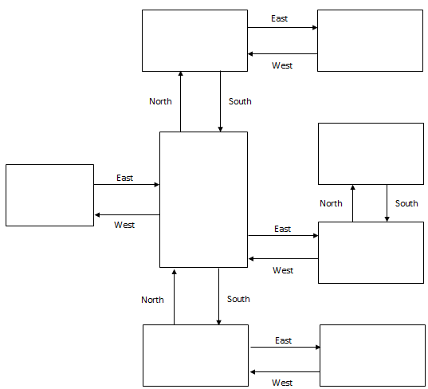
Malice
Item: Vial 3
Turmoil
Item: Vial 2
Sorrow
Item: Soulshield Amulet
Calamity
Item: Vial 1
Cruelty
Item: Sigil Stone
Awakening
Start
Agony
Item: Holy Urn
Hall of Entrapment
Villain: Abaddon

Pseudocode or Flowchart for Code to “Move Between Rooms”
Input direction, assign to user input
Split user input by a space, assign to next move
Access the first element of next move and title case, assign to action
If length of next move is greater than 1
List slice next move from element 1 to the end, assign to item
Access element 1 of next move and title case, assign to direction
Join item with space and title case

If action equals go
Try
Setting current room to direction, assign to current room
Print you travel [direction], assign to message
Except
Print you can’t go that way

Pseudocode or Flowchart for Code to “Get an Item”
If action equals get
Try
If item is equal to current room’s item
If item is not in inventory
Add the current room’s item to inventory list
Print you grab [item]
Else
Print You already have the [item]
Else
Print no [item] found
Except
Print no [item] found

